What Heat Pump System Is Right For My Home?

February 8, 2019

Brand name selection:
It is usually a very good idea to stick with well known brand names such as LG, Samsung, Mitsubishi, Carrier. The brands you never heard of and can't find a website for are best to stay away from, because they have a history of being prematurely discontinued from the market, along with available parts.

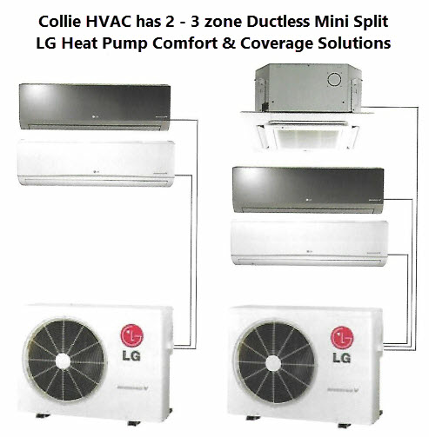0

Efficiency Levels:
Common units of measurement for Heat Pump Systems to consider are: COP, HSPF, EER/SEER RATINGS, BTU RATING (compared to its maximum rated BTU at +8c outdoor temperatures). Generally, the higher these readings compared to other brands or models are, the better.

Outdoor temperatures to consider:
The colder the climate in different areas of the world, is something to be considered. The average daily low temperature in Nova Scotia is approximately -8C. These heat pump systems all lose efficiency and heating capacity as the outdoor temperatures drop. (lower Btu, % of rated Heating Capacity, and COP data).
A few things to look into first when glancing at system efficiency and operating data. 1) Rated BTU output for the system. 2) BTU output at -15c outdoor, and percentage of Maximum BTU Rating. 3) How cold of outdoor temps is the system rated to run down to.
After checking the above 3 sets of data, then start looking into COP Ratings at the 3 standard temperatures the government, and the industry uses as the 3 main outdoor temperature points to reference data from.
The 3 temperature reference points are:
(1) +8c
(2) -8c
(3) -15c

Example: LG BASE MODEL HSV3 vs. LG PRESTIGE MODEL
Let's consider both models to be rated at 12,000 BTU.
Also, keep in mind that at the Reference point at +8c, most Ductless Mini Split Heat Pump Systems have a slightly higher output than the BTU rating of the system, due to the miracle of Refrigeration and technology. BONUS!
Data Reference Chart:

LG Model | 12000 BTU Base HSV3 | 12000 BTU PRESTIGE
@ +8c: Max BTU / % of rated / COP | 13,300 BTU / >100% / 3.9 | N/A
@ -8c: Max BTU / % of rated / COP | 10,142 BTU / 76% / n/a | N/A
@ -15c: Max BTU / % of rated / COP | 8,535 BTU / 64% / n/a | 13,720 BTU / 101% / 2.89
Low Temperature Operation down to: | -20c: 8287 BTU / 62% / n/a | -25c: 9520 BTU / 70% / 2.13

BOTH ABOVE SYSTEMS ARE RATED ENERGY STAR.

Lifestyle and Existing Structure and Existing Heating Conditions
The design and square footage of your home can affect your choice of a new system.
Some specific examples:
- home size
- bedroom sizes
- open concept or not
- long hallways or not
- how many levels
- insulation value of home
- how many windows, how big, how efficient.
- how airtight is the home
- what kind of existing heat available, how much life expectancy does it have
- Do you have a wood stove you love using and get free wood? You can't beat free, but a basic model heat pump is perfect for that situation. Much of the time in colder weather the homeowner will use the wood stove quite a bit. In the spring, fall, and warmer winter days, the heat pump is King!
- If you have high electric bills in the heating season, you have baseboard heaters in a bigger home, the Prestige might be a better option for you if the higher initial cost of installation is within your budget.
If you have an old expensive to run oil furnace, you might want to eliminate that whole system, and the utility fees that come with having the oil utility service. Get rid of that extra customer, maintenance and repair fees, and install your heat pump and a few emergency heat baseboard heaters in your home and your golden!
I'll get into explaining other helpful information about heat pumps, HSPF and COP ratings in another post. For now, I think you have some good information to give you a better idea of how to choose a system good for your needs. If you have more questions give Kevin at Collie HVAC
a call: 902-523-4822 or go to our website: www.colliehvac.ca and send a message to us right on the contact page on the site.

LET MAN'S BEST FRIEND BE YOUR BEST FRIEND.
GIVE COLLIE A CALL, OR PRESS SEND.
Best Regards, Kevin Sullivan

Please support and donate to SPCA NOVA SCOTIA if you can spare a little.

